ET0887 Practical 1 - HTML
- [Easy] HTML redirect using <meta>
<meta> tag have many functionalities including redirecting a web page (perhaps due to outdate page). You can set the page to redirect to another URL or HTML file.

Elements to use:
<meta>, http-equiv and content

Filename: page1.html
Redirect to page2.html in 5 second. Put some text in the body of page1.html

Filename: page2.html (same directory as page1.html)
This page will redirect to URL (http://www.google.com) in 5 second. Use “./page2.html” to tell the browser to redirect to page2 in the same directory. Also put some text in the body so that you know it is page 2.

Running:
Use web browser such as chrome or edge to open the file (File > Open or use explorer > right click on file > open with)

Expected Output:
After you open page1.html as file in web browser (e.g. Chrome), you should see after 5 seconds page1.html is redirector to page2.html. After another 5 seconds, your browser will be redirected to www.google.com.

Reference:
Study <meta> tag here (https://developer.mozilla.org/en-US/docs/Web/HTML/Element/meta). Look at http-equiv and content attribute.

- [Intermediate] Using HTML5 template (section 1.2.4) and Visual Studio Code to create HTML

Elements to use:
<p>, <br>, and character entities

Reference:
Refer to the character entities from the web such as: https://www.w3schools.com/html/html_entities.asp

Notes:
Sometimes when you are writing content with special symbols. For example, symbol & can be represented in HTML as &amp;

Content to show:

// Your First C++ Program
#include <iostream>

int main() {
std::cout << "I’m learning character entities (&, ", ', ©, ®, etc.) in HTML";
return 0;
}

Expected Output:
Use paragraph, line break and character entities to show the content above. Don’t forget the indentation in the source code (give it 4 spaces of indentation).

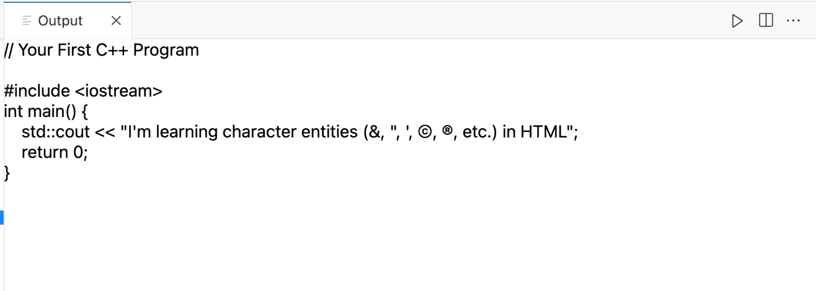
Sample output in Visual Studio Code HTML Play
- [Intermediate] Using HTML5 template (section 1.2.4) and Visual Studio Code to create HTML

Elements to use:
<p>, <br>, <img>, width, alt

Image links:
- Ritchie: https://en.wikipedia.org/wiki/Dennis_Ritchie#/media/File:Dennis_Ritchie_2011.jpg
- Ritchie & Thompson: https://upload.wikimedia.org/wikipedia/commons/1/1b/Ken_Thompson_and_Dennis_Ritchie--1973.jpg
- PDP 7: https://upload.wikimedia.org/wikipedia/commons/5/52/Pdp7-oslo-2005.jpeg

Content Text:
C, computer programming language developed in the early 1970s by American computer scientist Dennis M. Ritchie at Bell Laboratories (formerly AT&T Bell Laboratories). C was designed as a minimalist language to be used in writing operating systems for minicomputers, such as the DEC PDP 7, which had very limited memories compared with the mainframe computers of the period. The language was devised during 1969–73, alongside the early development of the UNIX operating system. It was based on CPL (Combined Programming Language), which had been first condensed into the B programming language—a stripped-down computer programming language—created in 1969–70 by Ken Thompson, an American computer scientist and a colleague of Ritchie. Ritchie subsequently rewrote and restored features from CPL to create C and eventually rewrote the UNIX operating system in the new language.
As the UNIX system was enhanced, a series of changes took place in C between 1977 and 1979. During this time a description of the language became widely available through a book, The C Programming Language (1978), by Brian W. Kernighan and Ritchie. In the mid-1980s it became important to establish an official standard for C, since it was being used in projects subject to commercial and government contracts. In 1983 the American National Standards Institute (ANSI) set up a committee that further amended and standardized the language. Since then C has been referred to as ANSI Standard C, and it remains popular in the world of UNIX-like operating systems. C also became one of the most common programming languages used for writing other system software and applications. Descendants of C include Concurrent C, Objective C, C*, C#, and the widely used C++. The programming language Java was introduced in 1994 as a simplified subset of C for deployment over the Internet and for use in portable devices with limited memory or limited processing capabilities.

Expected output:
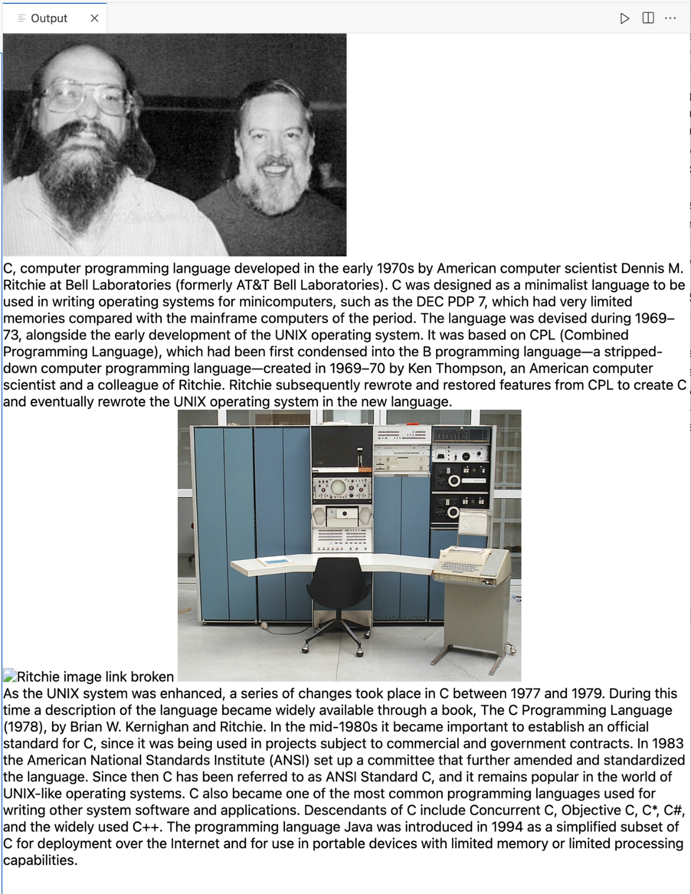
- [Hard] Lists, composite unordered and ordered lists. Using the data given below, your challenge is to create a nested list display of the data following the format of the expected output.

Elements to use:
<ul>, <ol>, <li>

Use the following data for content:
Apple | MacBook Pro | Ultrabook | 13.3 | Intel i5 | 8GB | 1.37kg | $1339.69
Apple | MacBook Pro | Ultrabook | 15.4 | Intel i7 | 16GB | 1.83kg | $2537.45
Apple | Macbook Air | Ultrabook | 13.3 | Intel i5 | 8GB | 1.34kg | $898.94
Apple | MacBook 12" | Ultrabook | 12 | Intel M m3 | 8GB | 0.92kg | $1262.40

Expected Output:
See the output of Visual Studio Code’s HTML Play given below:
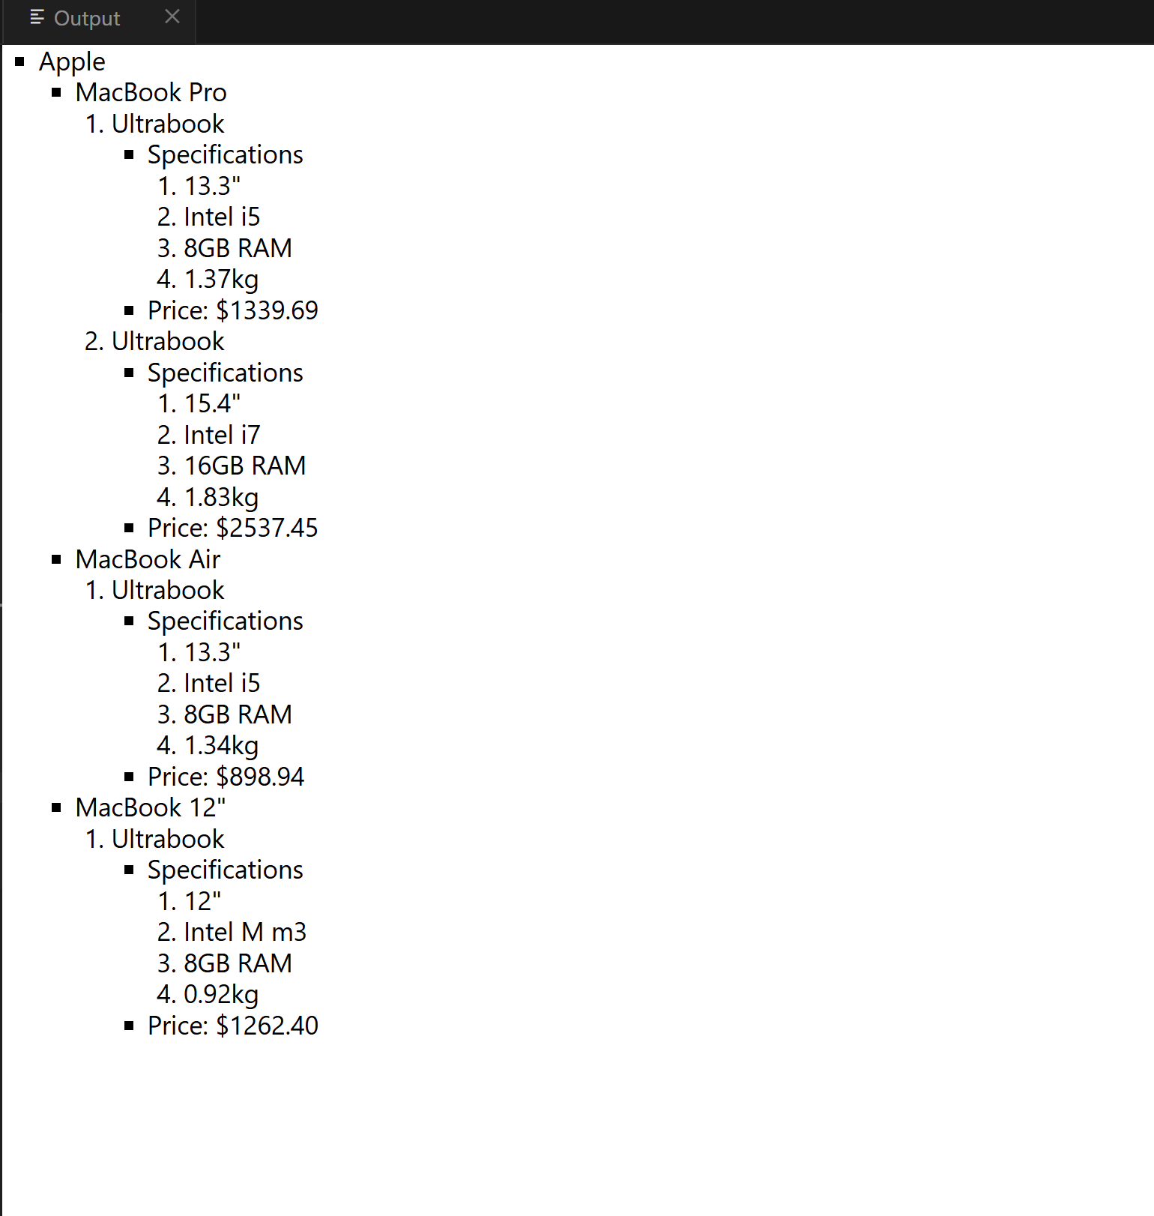
- [Intermediate] Video & Audio
Sometimes you may want to embed a YouTube video in your web page. You probably recalled we have introduced inserting video in HTML using <video> tag. But you will find that it will not work with YouTube. Find & embedded a video from YouTube in your HTML.

Elements to use:
<iframe>

Hints:
Embedding YouTube video is similar to sharing them. Look for share button on youtube and then copy the embedded HTML (iframe).

Expected Output:
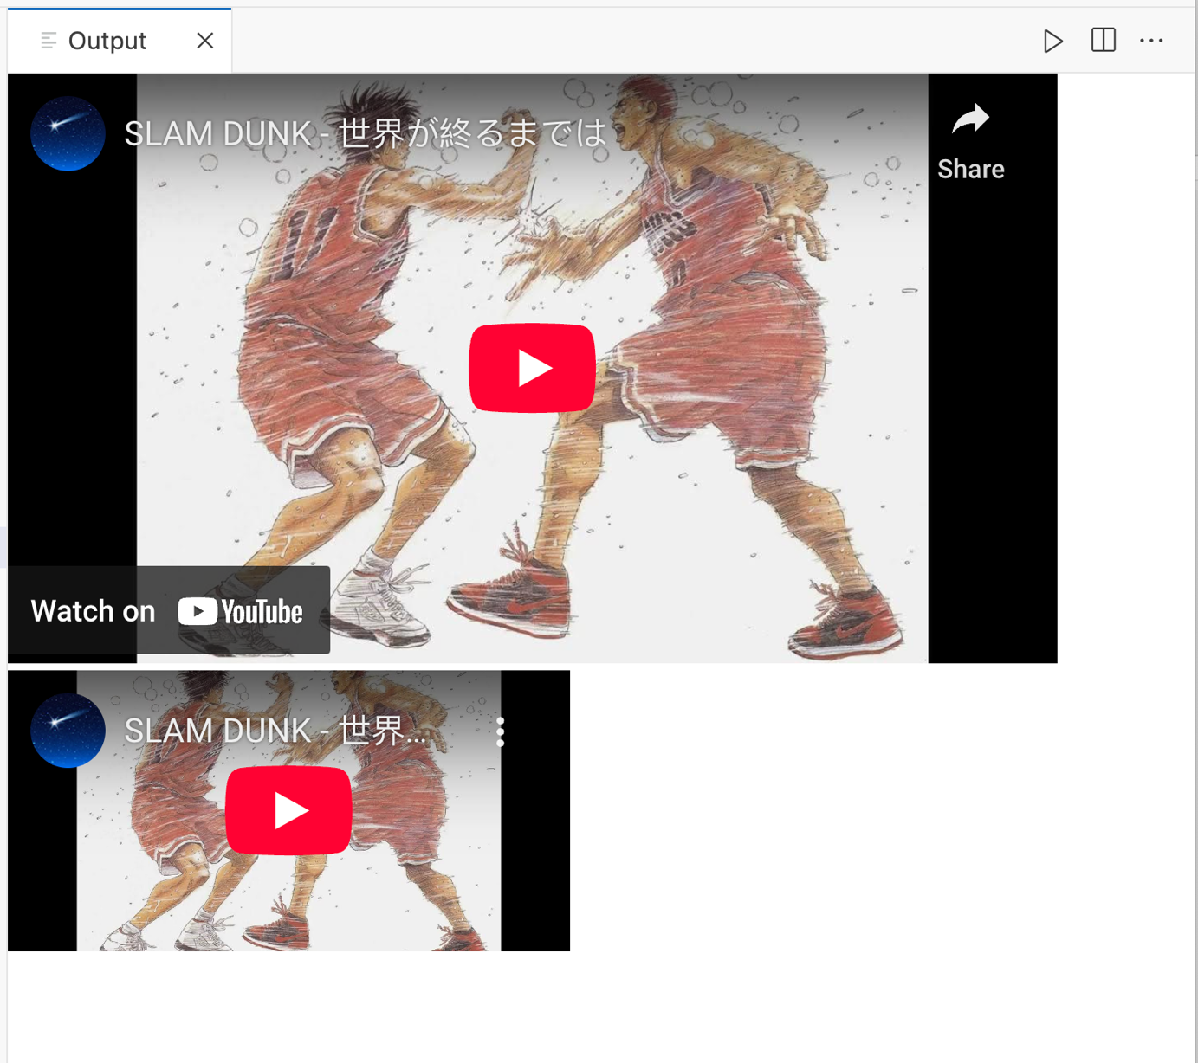
- [Easy] Create a HTML page with text and image. See the expected output and compare it with what we really want (you will do it in assignment 2). Try to understand that you can’t put text at foreground and image as background. This requires new knowledge.

Elements to use:
<img>, <h1>

Expected Output:
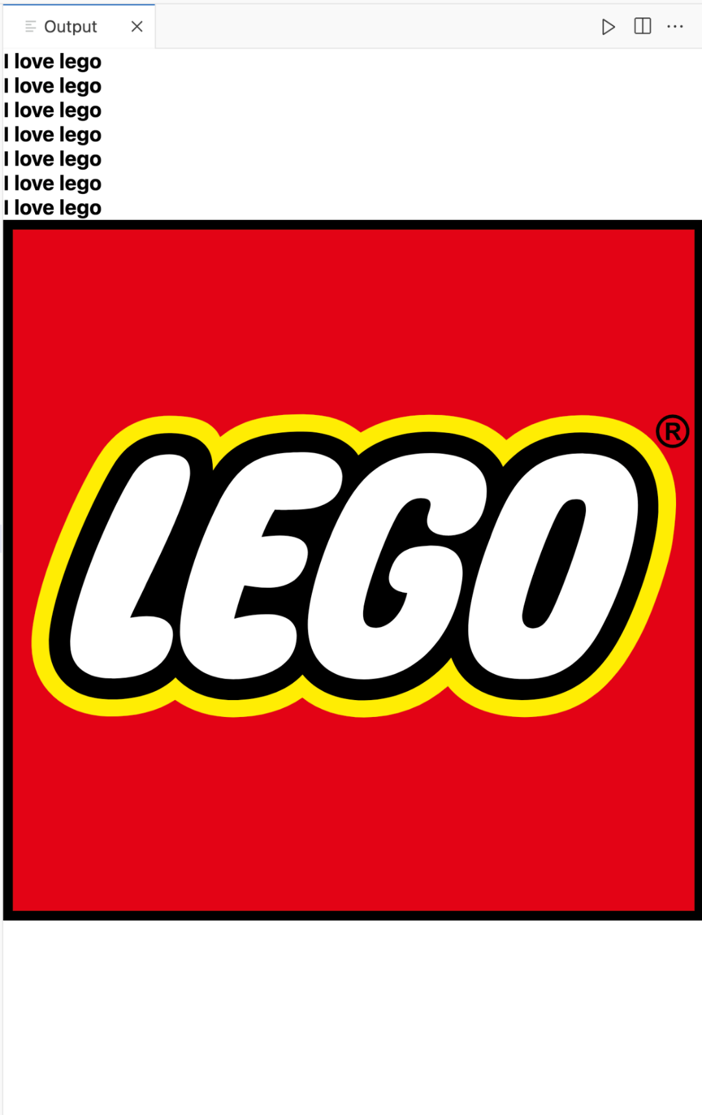

- [Hard] Create HTML with table. You will use colspan and rowspan to format the table.

Elements to use:
<table>, <thead>, <tbody>, <tfoot>, <tr>, <td>, <th>, rowspan, colspan
Use rowspan when the cell takes up multiple rows of space. Use colspan when the cell takes up multiple columns of the space.

Data given:
Apple | MacBook Pro | Ultrabook | 13.3 | Intel i5 | 8GB | 1.37kg | $1339.69
Apple | MacBook Pro | Ultrabook | 15.4 | Intel i7 | 16GB | 1.83kg | $2537.45
Apple | Macbook Air | Ultrabook | 13.3 | Intel i5 | 8GB | 1.34kg | $898.94
Apple | MacBook 12" | Ultrabook | 12 | Intel M m3 | 8GB | 0.92kg | $1262.40

Expected Output:
The table has a head section (bold & row 1-3) when we create using <th>. Group the head section using <thead>. Some of the head section span over multiple columns.

In HTML Play, the expected output is as follow:
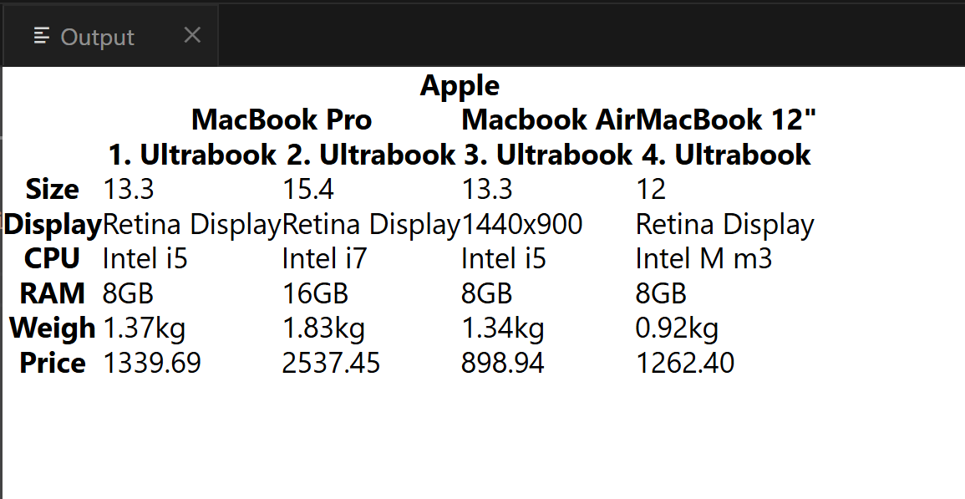

Hint:
The cell structure is more obvious with borders. Topic on table border will be cover in Chapter 2 CSS. So here, it is only for you to see the cell structure more clearly. You only need to work on the expected result above.
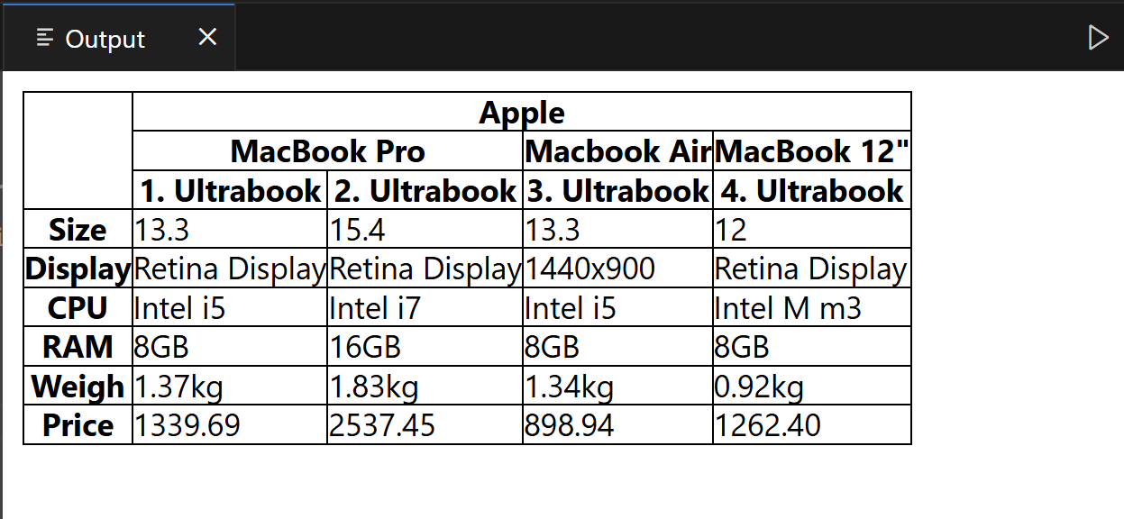

The word “deprecated” means outdate and it is slowly being removed. Suggestion is not to use it (e.g. border= attribute)

Reference:
https://developer.mozilla.org/en-US/docs/Web/HTML/Element/table

- [Intermediate] Create HTML form.
<form> element is used to send data to backend. In this exercise, you will not send the form to any backend. We can examine the URL to confirm if the form data sent is as intended.

Elements to use:
<form>, <input>, <select>, <option>, <label>, type, name, id, required

Usage for <label>:
You can associate <label> to an <input> by adding id attribute to <input> element. For example, cheese in <label> element is associated with id=”cheese”:

<label for="cheese">Do you like cheese?</label>
<input type="checkbox" name="cheese" id="cheese" />

Usage for name attribute:
From time to time, you will find name=keyword in <input> element. You may dismiss the importance of this attribute use in conjunction with <form>. In fact, it is extremely critical to know and take note.

The keyword after name attribute is used for form submission. It will be submitted with the form as part of a key/value pair. For example, if you have the following in input.html:

<form>
Username: <input type=”text” name=”username” />
<input type=”submit” />
</form>

After you enter username and click on the submit button, you should see something like the following in the URL:

http://xx.xx.xx.xx/input.html?username=username_entered

Usage for submit button:
You will need to use <input> element set to type=”submit” in order to the form data to be sent to backend. It will not work with type=”button”.

These 2 buttons for <input> elements are different!
- type=”submit”
- type=”button”

Expected Output (without the purpose remarks):
Open the HTML file using web browser. Enter the data and verify that the URL part in red is same or similar as what you get:
file:///???/assignment9.html?customerName=jack&email=jack%40abc.com&product2=on&deliveryDate=2025-03-23&pay=cc
Note: The “???” will be different for everyone as it depends on where you store your file. So, you may ignore it.
